**Use Case Name** **Read the Rules**

Related Requirements None

Goal In Context To let the user view the rules of the game before playing.

Successful End Condition The User is able to view the Rules Completely

Primary Actors Player

Secondary Actors None

Trigger Player press the see Rules Button.

Base Use Case None

Main Flow **Step Action**

1 The player clicks the see button.

2 The Rules Screen opens up. 3 The player clicks back.

4 Player is redirected to the start.

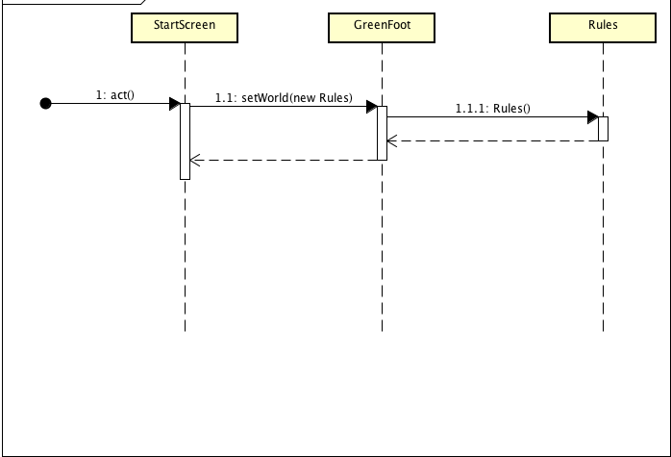

**Use Case Name Assign Packages**

Related Requirements None

Goal In Context To assign different types of packages to different vehicles

based on COR

Successful End Condition Different sized packages are assigned to different vehicles

Primary Actors Player

Secondary Actors None

Trigger Player presses different types of packages.

Base Use Case None

Main Flow Step Action

1 The player selects different type of packages.

2 The packages are assigned to

different vehicles based on COR.

Extensions **Step** **Action**

1.1 The player will not be able to assign

packages with count 0

Activity Diagram:

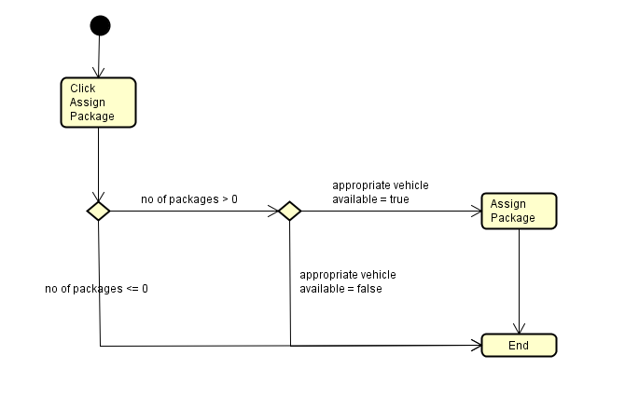

|  |  |
| --- | --- |
| **Use Case Name** | **Start Vehicle** |
| Related Requirements | None |
| Goal In Context | To start the vehicle with the packages assigned by the user |
| Successful End Condition | Vehicle goes into INTRANSIT state and starts delivering packages |
| Failed End Condition | No changes. |
| Primary Actors | Vehicle |
| Secondary Actors | None |
| Trigger | User presses the Start button |
| Included Cases | Update Balance |
| Main Flow | |  |  | | --- | --- | | **Step** | **Action** | | 1 | The system checks for the available vehicle, changes its state to INTRANSIT and starts the vehicle. | | 2 | The available vehicle starts and user is charged according to the assigned packages | |  | **include::Update Balance** | | 3 | The vehicle delivers the packages to the destination and returns to its starting place | |
| Extensions | |  |  | | --- | --- | | **Step** | **Action** | | 1.1 | All the vehicles are already in transit | | 1.2 | Nothing happens | | 3.1 | Game’s timer reaches zero before vehicle’s delivery | | 3.2 | User’s scorecard is displayed | |

|  |  |
| --- | --- |
| **Use Case Name** | **Update Balance** |
| Related Requirements | None |
| Goal In Context | To update the user’s balance |
| Successful End Condition | User’s balance is updated according to the vehicle he started |
| Failed End Condition | No change |
| Primary Actors | System |
| Secondary Actors | None |
| Trigger | System calls for updating users balance |
| Included Cases | None |
| Main Flow | |  |  | | --- | --- | | **Step** | **Action** | | 1 | The system checks for the type of vehicle that was started. | | 2 | The system updates the balance of the user according to it. | |
| Extensions | |  |  | | --- | --- | | **Step** | **Action** | | 1.1 | If user already has zero balance, nothing happens. | |

**Use Case Name**  **Start Game**

Related Requirements None

Goal In Context To present a start screen to the user, clicking on which the game begins.

Successful End Condition The player can view the first screen successfully before the game begins.

Failed End Condition None

Primary Actors Player

Secondary Actors **None**

Trigger Player presses the Run button and clicks on the start screen.

Included Cases **Display Result**

Main Flow **Step Action**

1 The player clicks on the Run button.

2 The player clicks on the Start screen. 3 The player is redirected to the screen displaying the game, and the player can now start playing the game.

4 The result is displayed.

**include::Display Result**

**Use Case Name**  **Display Result**

Related Requirements Start Game

Goal In Context The result of the game must be displayed to the user based on his performance.

Preconditions The player must have started the game.

Successful End Condition The result is displayed successfully.

Failed End Condition The result is not displayed.

Primary Actors Live game display screen.

Secondary Actors None.

Trigger The player is redirected to the display result screen upon game completion.

Main Flow **Step Action**

1 The user begins the game and starts playing it.

2 The number of packets used and the total money

spent on the packets is calculated.

3 The user is redirected to the results page where a

receipt having the result of the game, the cars used,

the number of cars used and the money spent on the

packages is displayed to the user.

Extensions **Step** **Branching Action**

1.1 The user does not start the game.

